TRANSFORMER ALGORITHM

A transformer processes all words in a sentence at once (unlike older models that went word-by-word), and figures out how much each word should "pay attention to" every other word to understand context. For example, in "the cat sat on the mat," when processing "sat," the model looks at "cat" strongly (who sat?) and less at "the."
This happens through a few key steps:
- Tokenization + embedding — text gets split into tokens and converted into number vectors
- Positional encoding — since all tokens are processed together, position info gets added so the model knows word order
- Self-attention — each token computes a relevance score against every other token (this is the "magic" part)
- Feed-forward layers — the attention output gets further transformed
- Stacking — this whole block repeats many times (layers), building deeper understanding
- Output — the final layer predicts the next token (or classifies, translates, etc.)

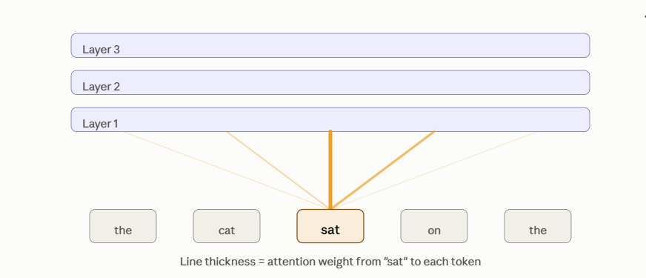

Detailed notes, BERT vs GPT-2 at each step:
- Define the problem
  - BERT → do you need to understand/classify text (sentiment, spam, intent, extract an answer)?
  - GPT-2 → do you need to generate text (complete a story, write a reply, produce content)?
- Data prep
  - BERT → needs labeled data: (text, label) pairs — e.g. reviews tagged positive/negative.
  - GPT-2 → needs raw unlabeled text — just a corpus in the style/domain you want it to write in. Zero data needed at all if you're just prompting it out of the box.
- Choose base model
  - Both are freely available via Hugging Face: bert-base-uncased, gpt2 (or gpt2-medium for better quality). No need to train from scratch — download pretrained weights.
- Adapt the model
  - BERT → attach a small classification/QA head on top of its output, then fine-tune on your labeled data (usually 2–4 epochs).
  - GPT-2 → either use it directly with good prompts (few-shot examples in the prompt), or fine-tune on your text corpus if you want it to mimic a specific style.
- Build & evaluate
  - BERT → check accuracy/F1 on a held-out test set.
  - GPT-2 → read the generations yourself, check coherence and relevance (no single "correct" metric); optionally track perplexity.
- Deploy & monitor
  - Wrap either in a Streamlit/Gradio app, host on Hugging Face Spaces (free) or a small cloud VM, and watch real usage to decide if you need more data or a bigger model

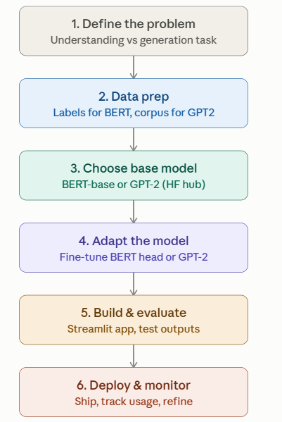
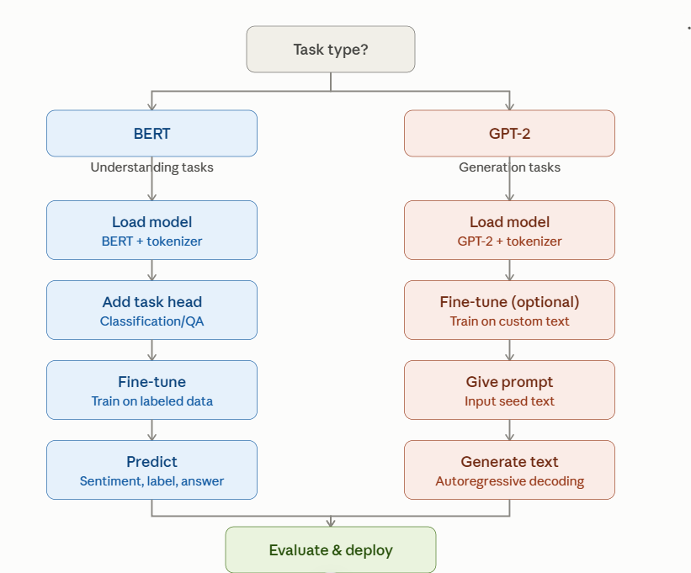

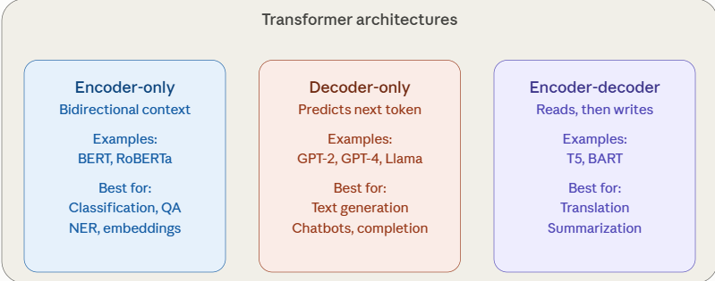

Once you've picked the right family for your task, every project — whether it's BERT, GPT-2, or T5 — follows the same underlying pipeline:

How to read this for a real project:
Step | BERT project | GPT-2 project
Load pretrained model | BertModel / BertForSequenceClassification | GPT2LMHeadModel
Adapt for task | Add classification/QA head, fine-tune on labeled data | Fine-tune on custom corpus, or just prompt directly
Output | Label, span, or embedding | Generated text sequence

Practical stack for projects:
- Library: Hugging Face transformers (handles tokenizer + model loading for both)
- Data: small labeled dataset for BERT (e.g. IMDB sentiment); plain text corpus for GPT-2 (optional, since it works zero-shot too)
- Compute: Google Colab free GPU is enough for basic fine-tuning
- Interface: Streamlit or Gradio for a quick demo UI
- Evaluation: accuracy/F1 for BERT tasks; perplexity or human review for GPT-2 generations

